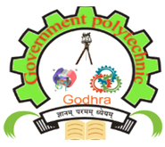

“Basics of Intellectual Property Rights and Patent Filing”
Under
Student Startup Research and Innovation

Venue  Shaheed Bhagatsinh Auditorium  Government Polytechnic,  Godhra | Date: 27-10-2023
SSIP 2.0 Cell, Government Polytechnic, Godhra
The "Basics of Intellectual Property Rights and Patent Filing" workshop held by SSIP 2.0 Cell of the Government Polytechnic Godhra on 27-10-2023 at 10.30am onwards. The expert Dr Mohsin J Dadi (Associate Professor, Department of Mechanical Engineering, Parul University) was invited by the Principal sir for the delivering the expert talk on the said workshop.
Executive Summary
The "Basics of Intellectual Property Rights and Patent Filing" workshop, organized by the SSIP 2.0 Cell, was a highly informative and engaging event. It aimed to educate participants on the fundamental concepts of intellectual property rights (IPR) and the process of patent filing. The workshop featured expert speakers and interactive sessions that provided valuable insights and practical knowledge on these critical subjects.
Introduction
Intellectual property rights play a pivotal role in protecting innovations, encouraging creativity, and promoting economic growth. Patents, in particular, are instrumental in safeguarding novel inventions. This workshop served as a comprehensive introduction to these concepts.
Workshop Objectives
The primary objectives of the workshop were as follows:
- To familiarize participants with the concept of Intellectual Property Rights (IPR): The workshop aimed to elucidate the various types of IPR, including patents, trademarks, copyrights, and trade secrets.
- To provide an understanding of the importance of patents: The workshop explored the significance of patents in protecting inventions and fostering innovation.
- To offer insights into the patent filing process: A step-by-step guide was provided on how to file a patent, including the documentation, legal requirements, and potential pitfalls.
- To address common misconceptions: The workshop aimed to dispel common myths and misunderstandings related to IPR and patents.
Workshop Agenda
The workshop was organized into several sessions, each focusing on different aspects of intellectual property rights and patent filing:
- Session 1: Introduction to Intellectual Property Rights
  - Overview of IPR
  - Types of IPR (patents, trademarks, copyrights, trade secrets)
  - Importance of IPR in innovation
- Session 2: Patents and Their Significance
  - In-depth discussion on patents
  - Case studies highlighting the role of patents in innovation
- Session 3: The Patent Filing Process
  - Step-by-step guide to patent filing
  - Required documentation and legal formalities
- Session 4: Common Myths and Misconceptions
  - Debunking myths about patents and IPR
- Session 5: Interactive Q&A and Panel Discussion
  - Participants had the opportunity to interact with experts and seek clarification on their queries.
Key Takeaways
The workshop provided participants with several key takeaways:
- A solid foundation in understanding different types of IPR and their importance in protecting intellectual assets.
- An appreciation of the critical role patents play in promoting innovation, research, and development.
- Practical knowledge about the patent filing process, including the documentation required and legal obligations.
- The ability to differentiate between myths and facts surrounding IPR and patents.
- Networking opportunities and access to experts in the field.
Conclusion
The "Basics of Intellectual Property Rights and Patent Filing" workshop organized by the SSIP 2.0 Cell was a resounding success. It equipped participants with a better understanding of IPR and patents, empowering them to protect their innovations and contribute to the growth of innovation ecosystems.
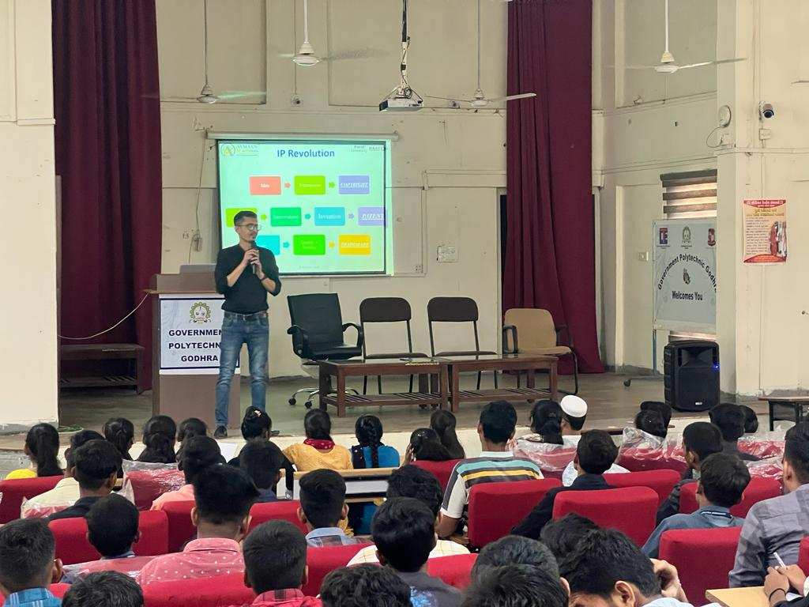
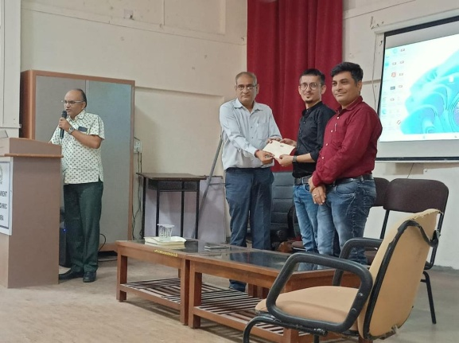
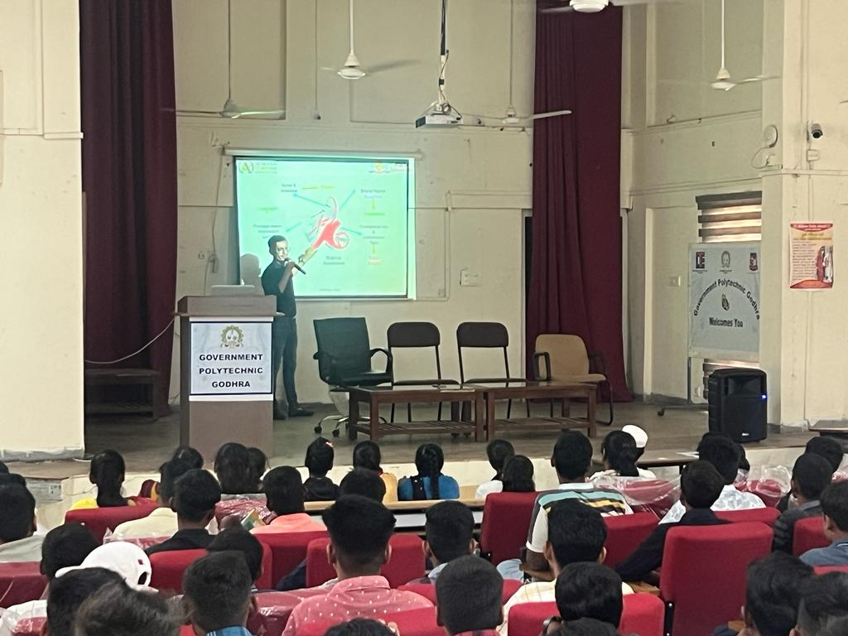
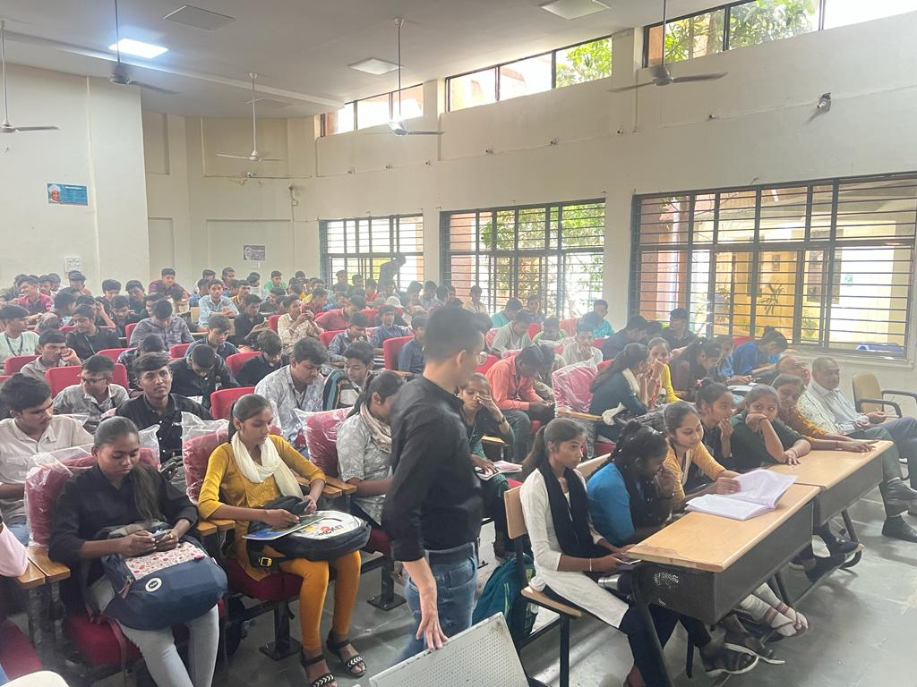
The workshop received positive feedback from attendees, who praised the quality of the content, the expertise of the speakers, and the interactive nature of the sessions. The SSIP 2.0 Cell is commended for its efforts in providing valuable education in the realm of intellectual property rights and patent filing.
Glimpse of the Event

